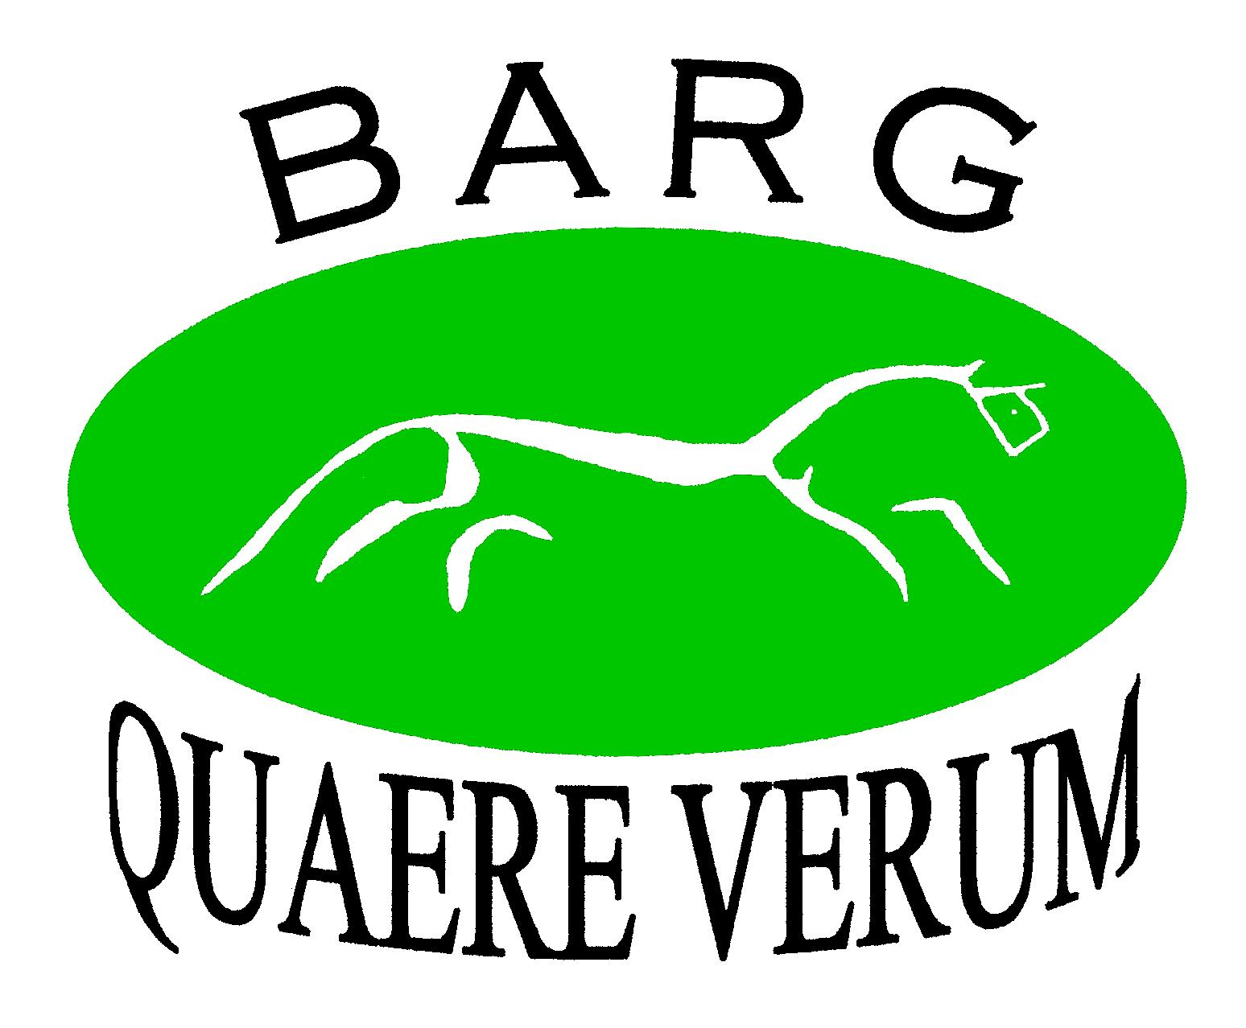
The Berkshire Archaeology Research Group

JOINING THE BERKSHIRE ARCHAEOLOGY RESEARCH GROUP 2025-2026
you do not need to have experience, come and learn with us; however you do
need to be 16 years of age or over

Welcome to BARG (please tick or highlight as appropriate):
◻ Single membership and insurance is £15
◻ Joint membership and insurance is £20 (2 people at one address)

Please tick or highlight preferred payment method:
◻ Cheque payable to Berkshire Archaeology Research Group
◻ Electronic payment please ask for details from the Treasurer (see over)
◻ Standing order please ask the Treasurer for the appropriate form (see over)

Contact details
These will be stored on a computerised membership database used solely for the purposes of the Group. By supplying these contact details you consent to the committee using them to administer your membership of the Group – please only supply those details which you are happy for us to use.

Title(s) and Name(s)
(please print)
Address
Home telephone number
Mobile phone number
Email address

Please delete yes or no as appropriate
I/We would like to receive the newsletter by email | Yes/No
I/We would like to receive email updates from the BARG committee & project leaders concerning the Group’s activities (fieldwork, meetings, visits etc) | Yes/No
I/We agree to the above information being included in a membership list that may be given to any Group member on request to facilitate communication within the Group | Yes/No

Signature Date

Please Turn Over

Berkshire Archaeology Research Group
joining form continued
Please tell us what activities within archaeology interest you

I would like to join in with (please tick or highlight as appropriate)

◻ Excavation
◻ Geophysics
◻ Fieldwalking
◻ Hedgerow surveying
◻ Woodland surveying
◻ Finds processing
◻ Photographing finds
◻ Workshops on different archaeological topics e.g. Roman pottery or identifying animal bone
◻ Cleaning and repair of equipment
◻ Monitoring, or maintenance of archaeological sites with Friends of Ancient Monuments (FOAM)
◻ Field trips (getting to know the archaeology of Berkshire)
◻ Field trips (sites outside the county)
◻ Archive up-dating
◻ Proof reading
◻ Quarterly Open meetings (QOMs) with an invited speaker and /or speakers from the Group
◻ Giving talks on your own archaeological projects and interests
◻ Social events

Please tell us what experience you have within archaeology, if any:

Please complete and send to the BARG Treasurer:

Roger Sym, 197 Halls Road, Tilehurst, Reading, Berkshire RG30 4PT

or email to: Roger@PsrLtd.ndonet.com

Tel. 0118 942 7703

Many thanks!

